# Worksheet 1 – Introduction to Electronics

### Learning objectives

* You will learn what a sensor is, what it measures and why
* You will be familiar with basic electronic components
* You will be able to build simple circuits from electrical schematics
* You will evaluate the accuracy and limitations of certain types of sensors
* By the end of this lesson, you will have built 2 contact sensors and 2 light gate sensors

### You will need

* Lab power supply
* Breadboard
* A pair of wire cutters
* Wire
* Multi meter
* The electronic components your teacher has given you

### Safety notice

Always turn off your power supply when modifying your circuit. This will help prevent damage to your components.

### How breadboard works

Your breadboard has hundreds of little holes which you can plug in wires and components. These holes are connected. The top and bottom two rows are connected from left to right, and the middle rows are connected from top to bottom. This means if you plug two things together in the same row, you don’t need any extra wires.

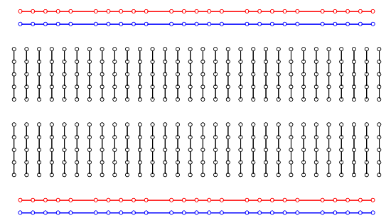

### Getting set up

Connect 2 wires to your power supply - one for the (+) red pin and one for the (–) black pin

Plug the wire connected to the red pin to the top row on your breadboard. Your set up should look something like this:

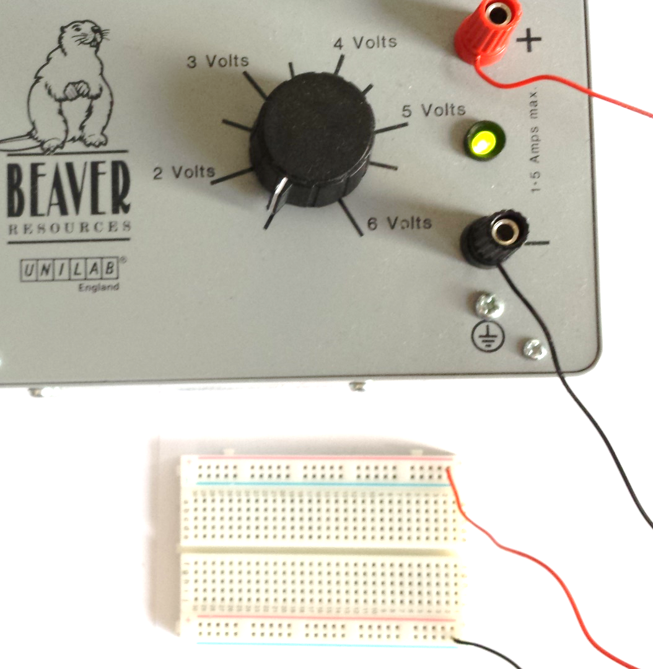

### Experiment 1

Pick up an LED - you’ll notice it has two metal pins. One pin is longer than the other – the longer one connects to the positive and the shorter one connects to the negative.

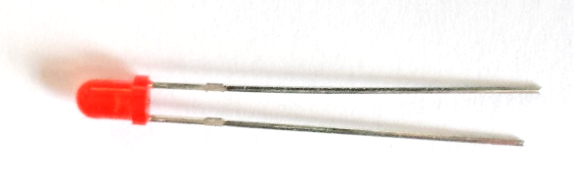

Pick up a resistor – you’ll notice that both wires are the same length. It doesn’t matter which way this component is connected.

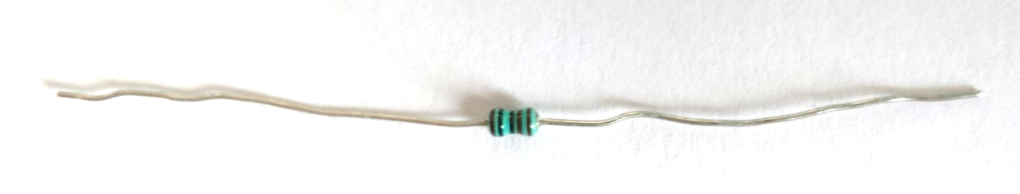

Plug the LED and resistor into your breadboard as show below. Make sure you plug the longer wire on the LED to the top of the board.

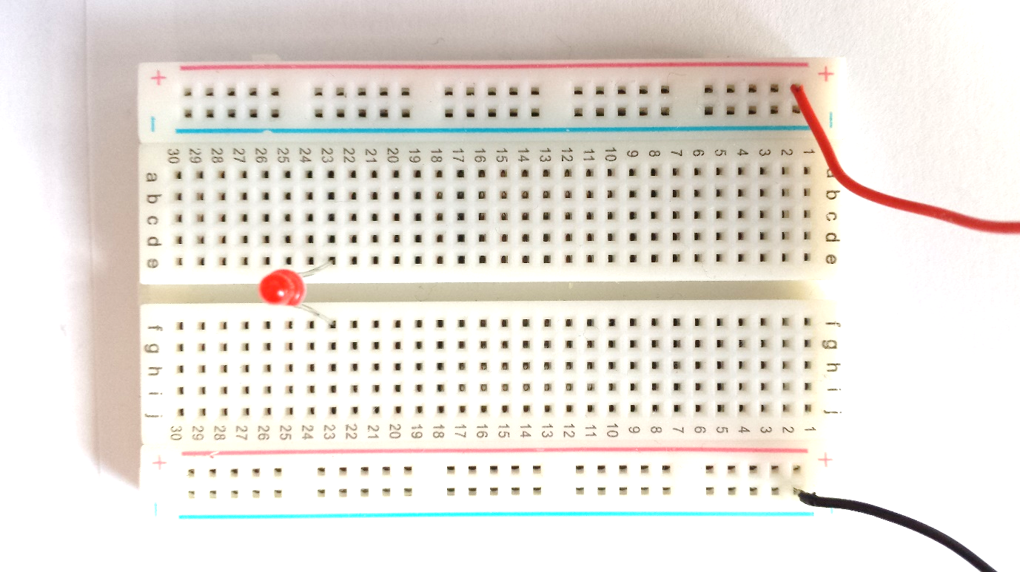

Now add a wire to link the top row of the board to the column that the LED is on. Add a resistor from the bottom row of the board to the column that the LED is on.

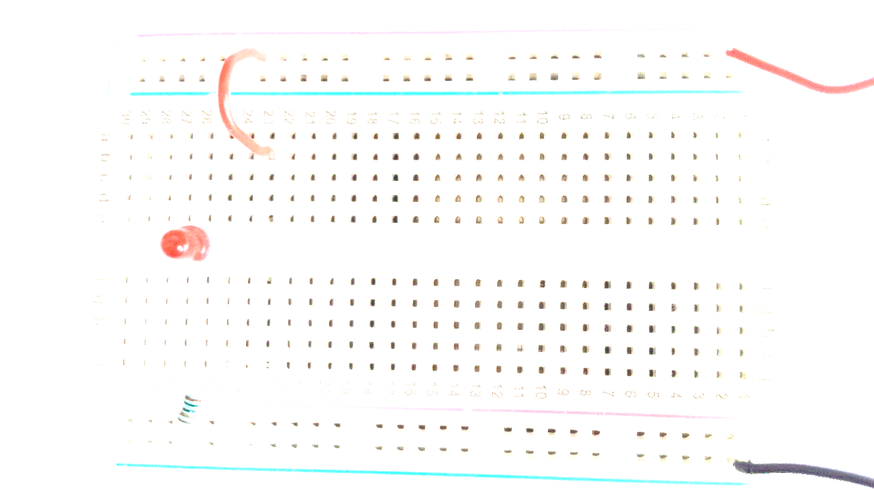

Set your power supply to 3 volts and turn it on. What happens to the LED?

Now set the power supply to 1 volt. What happens to the LED?

The circuit can be described in a technical drawing called a schematic. The schematic for the circuit you’ve just built looks like this:

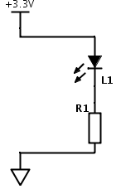

What do the following symbols represent?

|  |  |
| --- | --- |
| **Symbol** | **Meaning** |
| http://www.wpclipart.com/signs_symbol/electrical/IEC_symbols/IEC_LED_Symbol.png |  |
| http://www.build-electronic-circuits.com/wp-content/uploads/2013/03/schematic-symbols-resistor-europe.png |  |
|  | Wire/connection between components on the schematic |

Add 2 labels to the schematic above to show the resistor and the LED

### Experiment 2

Using the circuit you made in experiment one. Set the voltage on the power supply to 3 volts and turn it on.

Now unplug the black wire. What happens to the LED?

We can turn the LED off and on by making a break in the circuit. This is how a **switch** works.

*When the switch is* ***OPEN****, the circuit is disconnected. When the switch is* ***CLOSED*** *the circuit is completed and current can flow to the LED*

Using a piece of card, sellotape, tin foil and 2 wires, make your own switch as shown below:

1. Sellotape tin foil to both ends of a piece of cardboard
2. Sellotape a wire to each piece of tin foil
3. Fold the card in half
4. When the switch closes, the two pieces of foil should touch.

Remove the short wire on your circuit, and then plug in your switch onto your breadboard as shown below

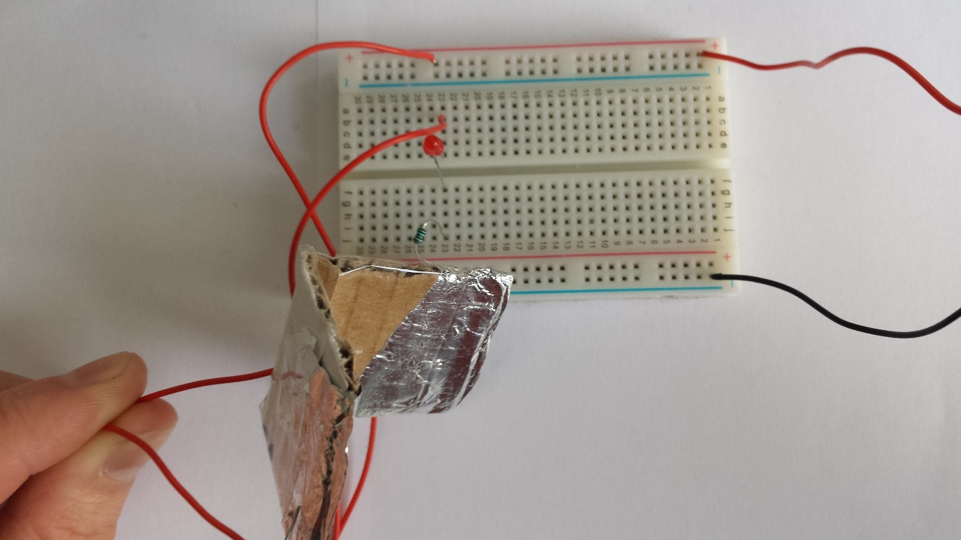

What happens to the LED when you press your switch closed?

What happens when you let go and your switch springs open?

The schematic symbol for a switch is shown below

|  |  |
| --- | --- |
| **Symbol** | **Meaning** |
| http://academic.greensboroday.org/~regesterj/potl/Electronics/ElectronicComponents/switch-spst.gif | Switch |

Add your switch to the schematic below

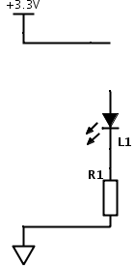

### Experiment 3

This experiment introduces a new electrical component called a **phototransistor**. The phototransistor is a component that uses light to control the voltage between its two pins.

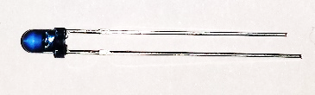

You’ll notice that the phototransistor also has a long pin and a short pin. Unplug your switch and connect your phototransistor onto your breadboard as shown below.

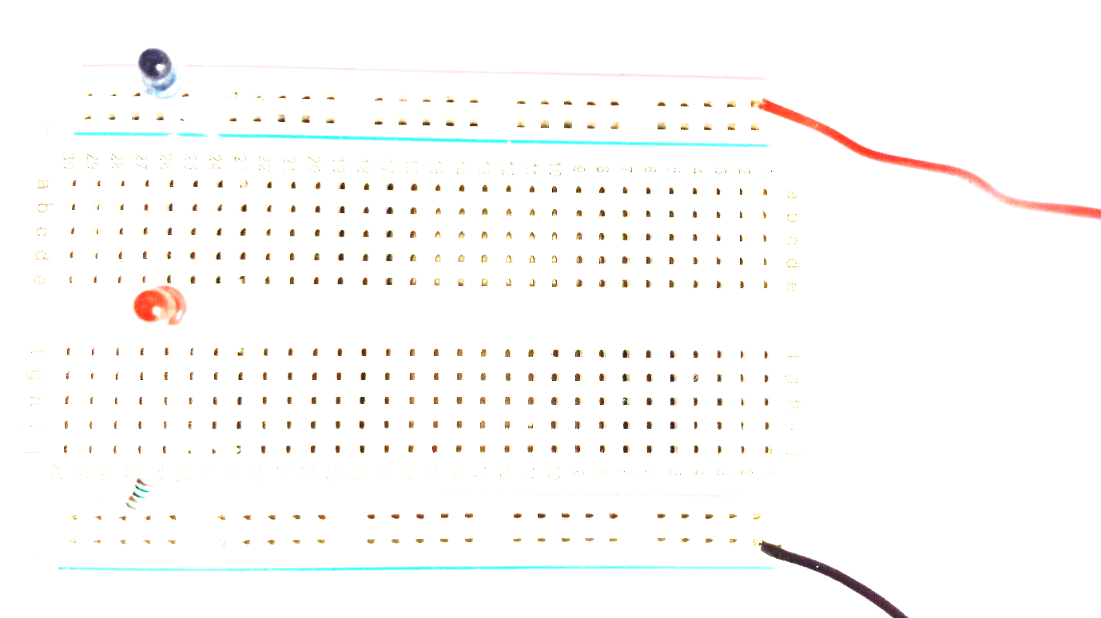

Turn on your power supply and use your multi meter to measure the voltage across the phototransistor.

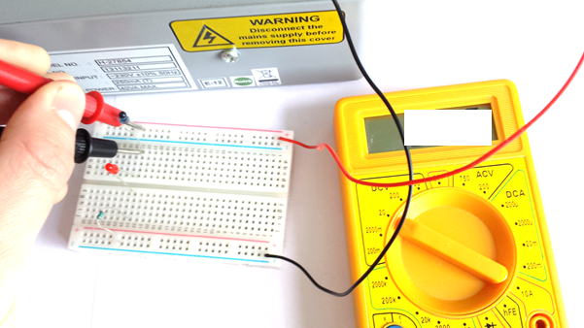

What voltage does your multimeter read?

Now cover the phototransistor with your fingers. What has the voltage changed to?

Describe in your own words what happens to the voltage when you change the light level for the phototransistor.

How bright was the LED?

The symbol for the phototransistor and multimeter are:

|  |  |
| --- | --- |
| **Symbol** | **Meaning** |
| http://www.daenotes.com/images/photo-transistor-symbol.png | Phototransistor |
| http://upload.wikimedia.org/wikipedia/commons/5/59/Voltmeter_symbol.png | Volt meter |

The schematic of the circuit you’ve just made is:

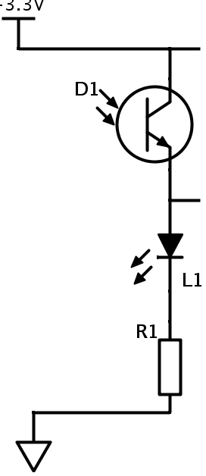

Add your multi-meter symbol to the circuit diagram.

### Experiment 4

You can use the phototransistor to make a light sensor. In this experiment, we’ll use the phototransistor to turn the LED on and off. You may have noticed only a small change in voltage when you used the phototransitor.

To make this sensor we will use 2 new components: a **transistor** and **potentiometer (variable resistor).**

The transistor acts like a voltage controlled switch. We can use this to switch the LED off and on when the voltage on the phototransitor goes high and low. The transistor **amplifies** the change in voltage.

*A* ***small*** *change in voltage across the phototransistor is amplified to a* ***greater*** *change in voltage across the transistor.*

The potentiometer is a special type of resistor that we can set the resistance of. We can turn the knob to set the sensitivity of our light sensor.

The transistor has 3 pins – called a collector, base and emitter. You identify these by looking at the shape of the transistor

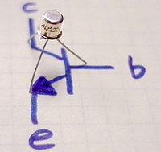 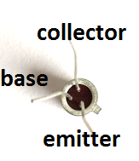

The potentiometer also has three pins. You can use your multimeter to measure the resistance between these pins.

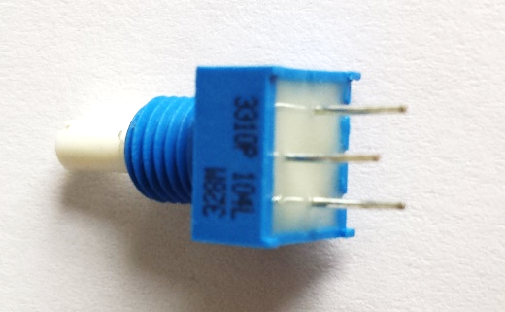

What is the resistance between the first and third pin?

Does this resistance change if you turn the knob?

What is the resistance between the second and third pin when the knob is turned half way?

What is the resistance between the second and third pin when the knob is turned all the way round?

What is the resistance when the knob is turned the other way?

The symbol for a transistor and potentiometer are:

|  |  |
| --- | --- |
| **Symbol** | **Meaning** |
| http://4vector.com/i/free-vector-npn-transistor-symbol-clip-art_116282_Npn_Transistor_Symbol_clip_art_hight.png | Transistor |
| https://encrypted-tbn1.gstatic.com/images?q=tbn:ANd9GcQYoMDooUz0EgNs8KYin30Gpofqq7Q9ki-SelNamWq7lMdpOSN7fg | Potentiometer  (Variable resistor) |

Remove all electrical components and wires from your breadboard.

Add the transistor to the middle of the circuit board. Make sure the collector and base pins are connected to different columns.

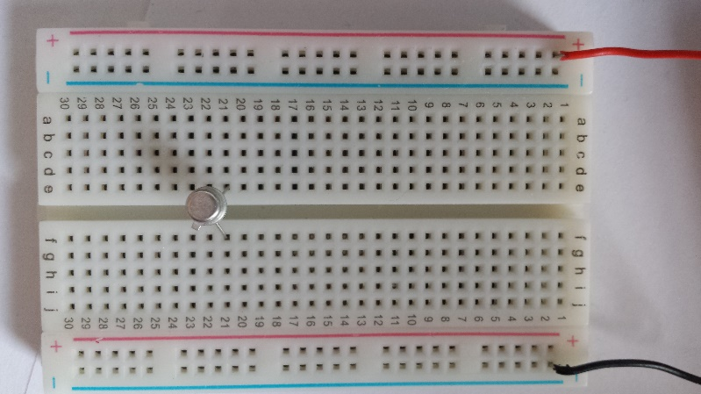

Connect a resistor between the collector pin of the transistor and the top row of the board. Connect the phototransistor between the base pin and the top row of the board.

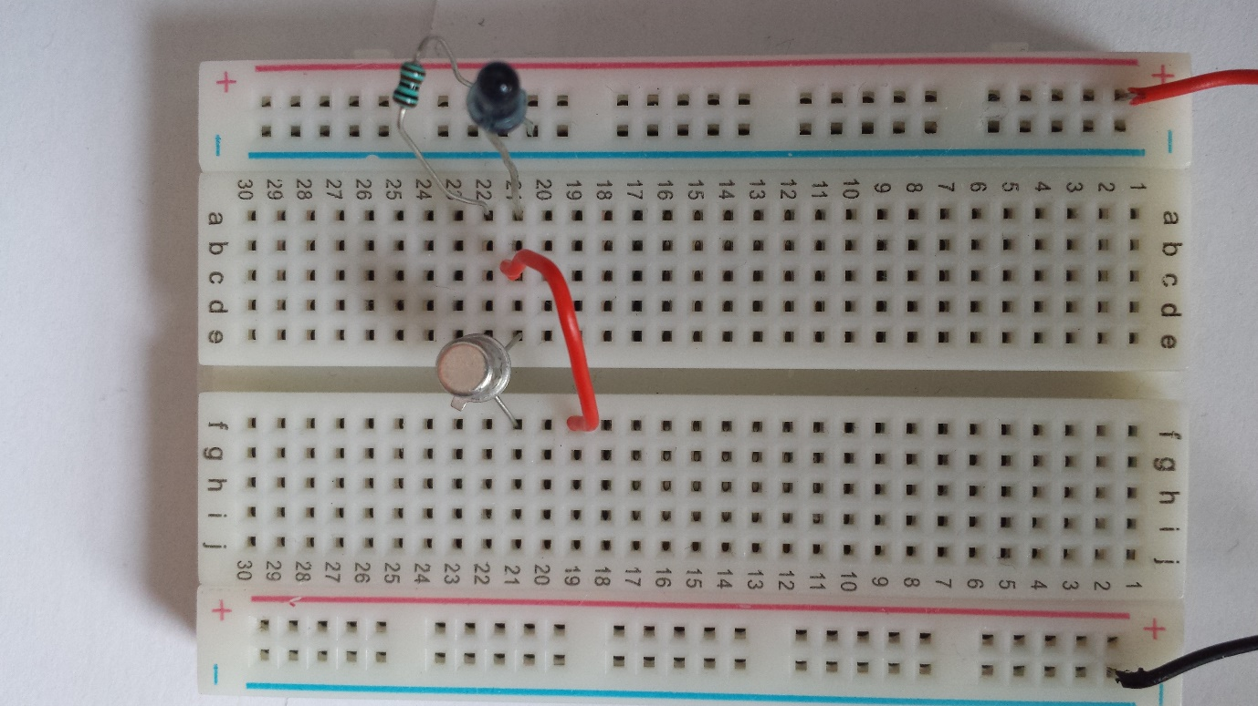

Add a wire to connect the base of a transistor to a free column on the breadboard – this is where we’ll connect our potentiometer.

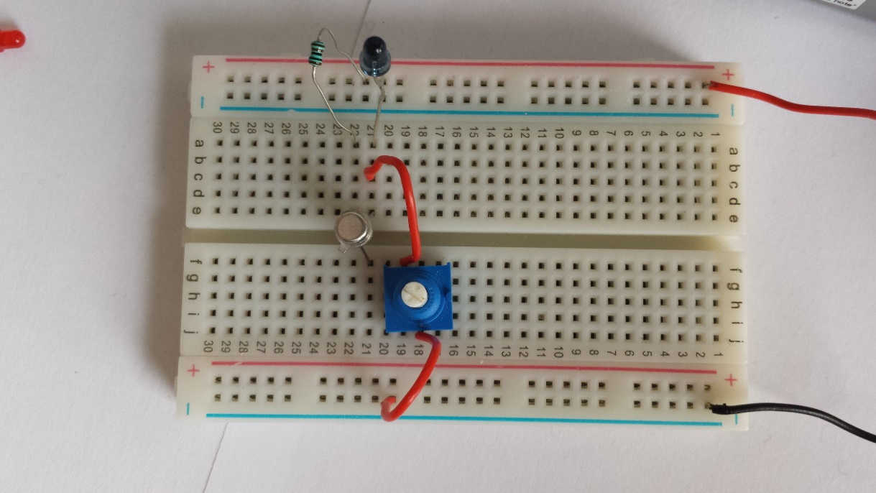

Turn on your power supply. You might notice your LED turn on, you might notice it stay off. If your LED is off, twist the knob on your potentiometer. If your circuit is built correctly then the LED will turn on.

Turn the knob on your potentiometer until you find the point where your LED only just turns on. You have not set the sensitivity of your light sensor. If you cover the phototransistor with your fingers, the LED should now turn off.

The schematic for the circuit you’ve just made is

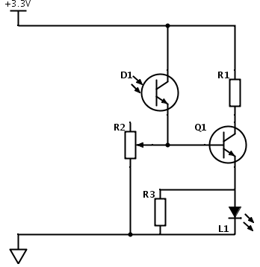

Label all the components on the schematic